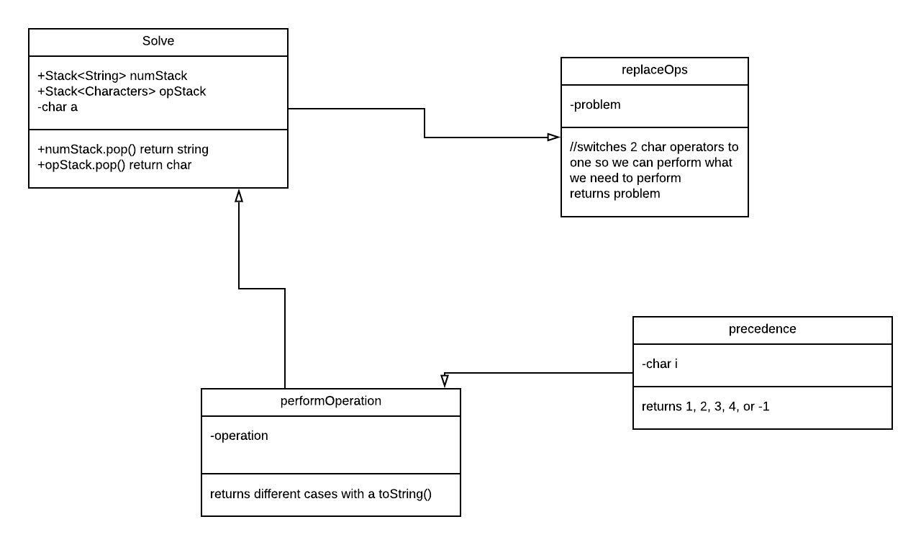**Infix Expression Parser**

Drew Donaldson

Alyssa Pettit

William Waugh

**System Design**

The program asks the user for a math problem. This is read as a string which is then stripped of white space and all characters are set to lower case. The formatted string is read into two stacks, one of integers for the numbers and another of characters for the operators. Operators are preformed on the integers in the proper order and the results are converted to string and output to console.

**Contributions**

Everyone worked on the project together simultaneously and reviewed and edited the code as a group. William wrote the report and the driver module, Drew made the UML diagram and the code to set up the stacks, Alyssa provided the test cases and the code to perform the operations.

**Improvements**

The code could be written to handle postfix operators as well but that was not required for this assignment.

**Test Cases**

1. 1 + 1

The program ads 1 to 1 and outputs 2 as expected.

1. (3 ^ 3) + 1

The program multiplies 3 to the power of 3 and adds 1

Output is 28 as expected.

1. 1 > 2

Statement is evaluated, 1 is not greater than 2, program outputs false (0).

**UML Diagram**

